Project: The Ωmega Vest
Date(s): 12/04/2014
Prepared by: Omar Halabi, Justin Parker, Ryan Foxworth, Seng Loong Yu, and Juan Lopez Marcano

Document status: __ Draft __ Proposed __ Validated _x_ Approved

1. Introduction
This document contains the system requirements for the Ωmega Vest.

1.1 Purpose of This Document
This document is intended to guide development of the Ωmega Vest. It will go through several stages during the course of the project:
- Draft: The first version, or draft version, is compiled after requirements have been discovered, recorded, classified, and prioritized.
- Proposed: The draft document is then proposed as a potential requirements specification for the project. The proposed document should be reviewed by several parties, who may comment on any requirements and any priorities, either to agree, to disagree, or to identify missing requirements. Readers include end-users, developers, project managers, and any other stakeholders. The document may be amended and reproposed several times before moving to the next stage.
- Validated: Once the various stakeholders have agreed to the requirements in the document, it is considered validated.
- Approved: The validated document is accepted by representatives of each party of stakeholders as an appropriate statement of requirements for the project. The developers then use the requirements document as a guide to implementation and to check the progress of the project as it develops.

1.2 How to Use This Document
We expect that this document will be used by people with different skill sets. This section explains which parts of this document should be reviewed by various types of readers.

Types of Reader
This document is primarily directed at a wide general audience of non-technical people who have either played a videogame or watched a video/film in the past.

Technical Background Required
No technical background is required of the reader to understand this document.

Overview Sections
In order to gain an overall understanding of the project, only “Section 1.3 Scope of Product” needs to be read.

1.3 Scope of the Product

The Ωmega Vest is intended to be the last missing piece to the intricate puzzle, that exists within the video/audio entertainment industry. More specifically speaking, the Ωmega Vest is a vest that the user wears while either playing a video game, or watching a piece of media, that drastically adds an all new level and intensity to the immersive experience that exists within the end-user/consumer. By integrating a state of the art vibratory system into the Ωmega Vest, the user is able to feel what is going on in the selected viewing media. For instance, imagine that you are playing a video or watching a video of a Jeep Wrangler driving over some rocks: the Ωmega Vest will then start to gently vibrate as it brings you into the driving experience. Suppose then that a giant boulder fell off of the top of a cliff and smashed said Jeep Wrangler, the user of the Ωmega Vest would then feel an intense vibration throughout their upper body.
However, the vibratory nature of the Ωmega Vest is not all that the vest has to offer; smells, scents, and even pneumatic implementations, are what makes the Ωmega Vest so legendary in nature. When wind is present within a videogame of another viewing media, the pneumatic capabilities of the Ωmega Vest will be utilized to create a rush of compressed that is directed at the user/consumer. The smells and scents dynamic that exists within Ωmega Vest, will be achieved by using the implemented pneumatic system, in conjunction with scent and smell dispensers. Therefore, when the user is viewing a piece of media, for instance, where they are walking through an orange grove, a mist of orange scent will be released into the air via the Ωmega Vest. The possibilities really are endless.

1.4 Business Case for the Product

Often times in life, the consumers of products do not understand why products need to be created, until they can visualize themselves bearing the fruit of said product; generally, that does not happen until after the product is created, or until a period of time passes after the product is released. With that being said, the full globalized entrepreneurial financial implications of Ωmega Vest can not be completely visualized until after the completion of the Ωmega Vest. However, vision and foresight are the two key fundamental capabilities and attributes that must be utilized when designing and engineering any product, and especially when it comes to the design and cultural systematic implementory integration of the Ωmega Vest. Although the University of South Florida’s surface goals are that of education and academics, they are still a private business that generates millions of dollars of revenue every year. In the event that our Ωmega Vest yields a business that generates revenue, as we can see with the Gatorade incident of the University of Florida, odds are that USF will sue us for a piece of the financial pie; and will probably even insist upon us giving them whipped cream for said pie. Thus, the Ωmega Vest would then definitely contribute to the goals of our institution, USF.
When it came to generating the demands for Ωmega Vest, such as its functionality, the creative process was actually rather short and conclusive. We asked ourselves, “What senses are left for our product to consume in the end-user/consumer;” the senses of “smelling,” and minimal “physical displacement” came to mind. Therefore, those are the senses that we decided to capitalize on when it came to designing and engineering the Ωmega Vest.

1.5 Overview of the Requirements Document

Vibratory Sub-System: The sub-system of vibrating motors that enable the Ωmega Vest to vibrate.

Pneumatic System: Composing of the external air compressor, along with the internally integrated pneumatic input and dispensary system.

Control Systems: Consisting of the output electrical signals generated by the microcontroller, via the written program and programmed script, along with the input signal control device that is located inside of the Ωmega Vest to control the pneumatic, vibratory, and scenting functions of the Ωmega Vest.

2. General Description

Upon investigating the market for a device that would capitalize upon the senses that are not typically used while watching a video or playing a videogame, we decided that we needed to create the Ωmega Vest. The Ωmega Vest is a vest that has capability to vibrate, dispense scents, and blow air, all while being simultaneously synced with a specific video game or video. Our end user base is set to everyone who watches videos/films, or plays video games. However, there will also be a technical audience that will be able to create user specified programming sequences for the Ωmega Vest. The possibilities for the Ωmega Vest are quite limitless.

2.1 Product Perspective

As a few users of the millions of users that exist, and co-exist, within the dynamic expansively diverse framework of the of the viewing and interactive media experience, it was fairly obvious as to why we were the ones who need/needed to develop this product. Entertainment, both as a metaphysical entity, along with a metaphorical substrate, and then back to the non-intricacies of the standardized media experience that we have all come to know and love, the need that the Ωmega Vest serves is so large and expansive that, we the designers, do not even know how extravagant of a need that it will serve. But in a cultural industry in which everyone wants the newest, greatest, and next step into the interactive media experience, the need for the Ωmega Vest expands across all temporal entities, all ethnic and religious backgrounds, in order to provide a truly robust product that customers will not only know, but they will love it as well. The engineers on the design team consist of Omar Halabi, Justin Parker, Ryan Foxworth, Seng Loong Yu, and Juan Lopez Marcano. Consequently, they are also the primary stakeholders, along with the sole developers, for the Ωmega Vest product. As afore stated, everyone who uses audio/video mediums of media will find great benefit by using our product, the Ωmega Vest.

2.2 Product Functions

Our product, known soley as the Ωmega Vest, provides the user with an accessorized vest that plays off of the unused senses of the user. More specifically, the Ωmega Vest generates synchronized vibrations, air blasts, and scents, that are programmed to occur synchronously with a specified desired videogame or a piece of audio/video media.

2.3 User Characteristics

When it came to deciding upon whom our user base of consumers would be, we quickly decided that Ωmega Vest would be a device that would be super user friendly. Our unofficial development slogan was, “So easy that your grandmother could use it.” By adhering to that demand of a user/consumer base, we were able to create a product, the Ωmega Vest, that would be usable by a wide audience of technical, along with non-technical, types of people. Yes, we will offer the users the tools to be able to program their own dynamic sequences utilizing all of the vibratory, scent dispensing, and air blowing capabilities of the Ωmega Vest, but the user is in no way required to do so. Anyone can use the Ωmega Vest; the only requirements of the user is to be able to strap on a vest, and to be able to attach a few cords and connectors.

2.4 General Constraints

Upon viewing the programmable demands of the Ωmega Vest, we decided to create the software needed in the computer programming language known as C#. We also concluded that the operating systems that would be supported will be limited to Windows, and perhaps Linux.

2.5 Assumptions and Dependencies

When designing the Ωmega Vest, we decided to utilize the Arduino Uno due to its deluxe infrastructure. Although this requires us to be dependant, we believe that the Arduino Uno and its subsequent versions will be available for future product. In the event that the Arduino Uno enterprise goes out of business, we are both fully qualified and fully confident that we can find a replacement in little to no time, should the occasion arise.

3. Specific Requirements

This section of the document lists specific requirements for the Ωmega Vest. Requirements are divided into the following sections:
- User requirements. These are requirements written from the point of view of end users.
- System requirements. These are detailed specifications describing the functions the system must be capable of doing.
- Interface requirements. These are requirements about the user interface, which may be expressed as a list, as a narrative, or as images of screen mock-ups.

3.1 User Requirements

A computer with USB connection
Purchase the Ωmega Vest
Download the software to run the system
Access to a 120V/60Hz wall outlet
Plug in the Arduino Uno,/air compressor packaging enclosure to the outlet
Connect the system enclosure to the computer via the provided USB cable
Connect the system enclosure to the vest via the given attachment cable
A movie/video clip
Load/unload/replace scent tubes when necessary

3.2 System Requirements

3.2.1 Software
The computer software is an application that will have basic playback features such as play/pause, stop, etc. The application will also read a comma-separated-value (CSV) file, parse it, and send serial messages to the microcontroller unit (MCU). For our design, we have chosen to use the MCU known as Arduino Uno. The Arduino Uno then receives the serial string messages sent by the computer, decodes it and sends out the electrical signals to the different components to imitate physical effects such as vibration and scents while watching the video being played.

3.2.2 Hardware
The computer will be connected to the Arduino Uno via USB. The Arduino Uno,and the air compressor will be in a packaging enclosure that will look like something similar to a desktop computer tower enclosure. The Arduino Uno, will be powered by the computer via the USB connection. The air compressor will be powered by a standard wall outlet. The air compressor will connect to the Arduino Uno, so that it can receive instructions. A cable will go from the system enclosure to the vest. Inside this cable will be three different links. The first set of links is a power cable which supplies power the vibration motors in the vest. The second link contains multiple wires that will connect to each vibration motor and servos that will actuate the scent cartridges and the air valves. Thus, the components will receive signals from the Arduino. The third link is a thin tube that will transfer the compressed air to the output shafts in the vest. The vibration motors will be installed in the vest in a symmetric pattern and the scent cartridges will be inside a box in front of the user to spray scent when indicated by the Arduino.

3.3 Interface Requirements
A computer interface is required to recognize in-use Ωmega Vests, as well as to load, sync, and play the desired video file. When the Ωmega Vest Player is initially executed, it appears as Image 1 below:
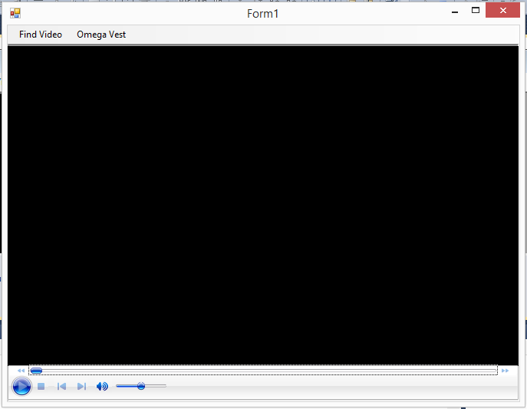
Image 1: The initialized Ωmega Vest Player

Then to begin the viewing experience, the ‘Find Video’ button in the top left corner is selected. This opens a Browse window in order for the user to select their desired video media content. After they have selected the video, the player may look something like Image 2:
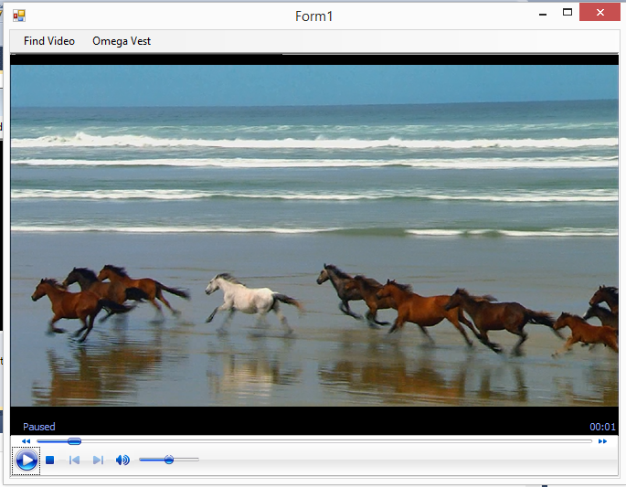
Image 2: The Ωmega Vest Player with paused video file

The next step would be enabling the Vest communication with the software. Clicking ‘Omega Vest’ opens a drop-down menu in order to detect and enable the vest. Selecting detect from the drop-down opens a small dialogue box as seen in Image 3. Pressing ‘Enable’ sets that specific vest as the one that the software will communicate with.
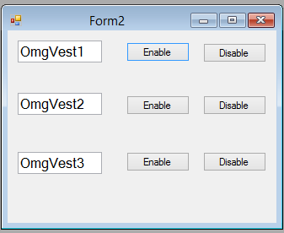
Image 3: Detection and Enabling of selected vest

When ‘Enable’ is clicked, the software will begin syncing. This will match the vest behavior with the film or video clip characteristics. A loading bar, as in Image 4, will appear in order to display the progress of the sync.
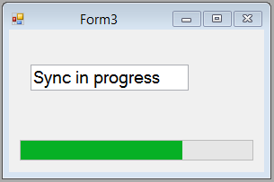
Image 4: Progress bar with a video sync in progress

4. Glossary

Arduino Uno: is a microcontroller board based on the ATmega328. It has 14 digital input/output pins (of which 6 can be used as PWM outputs), 6 analog inputs, a 16 MHz ceramic resonator, a USB connection, a power jack, an ICSP header, and a reset button. It contains everything needed to support the microcontroller; simply connect it to a computer with a USB cable or power it with a AC-to-DC adapter or battery to get started. For more information, see http://arduino.cc/en/Main/arduinoBoardUno

